1. Head to C:\RPSoftware\WampSetup. Install this file using all default options “vcredist_x64.exe”. This is Visual C++, it is needed for wamp to install and work correctly.
2. Now in C:\RPSoftware\WampSetup. Double click “wampserver3.0.6_x64_apache2.4.23_mysql5.7.14_php5.6.25-7.0.10” to begin wamp installer. Install with all default options. Click Finish and move to next step.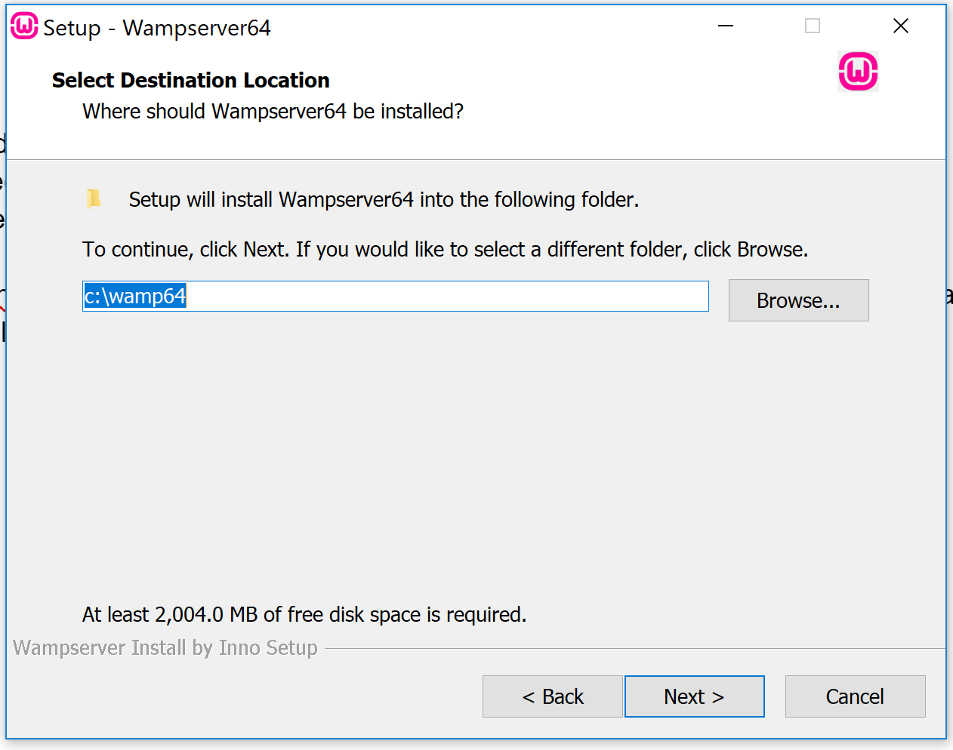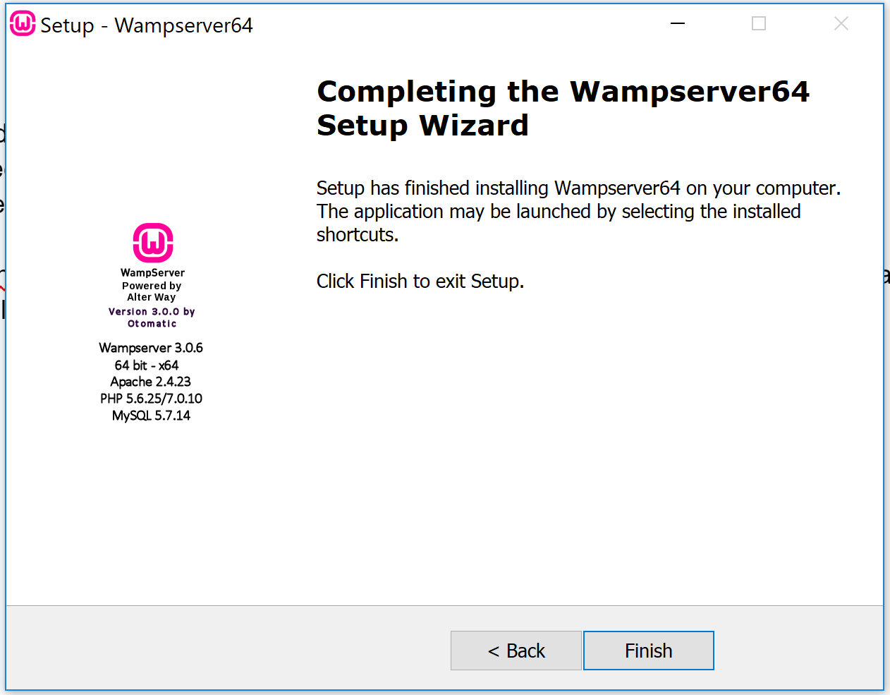
3. Now that wamp has been installed let us head over to the folder. Go to C:\wamp64 (Wamp directory). In this directory delete the “alias” folder and all of its contents. 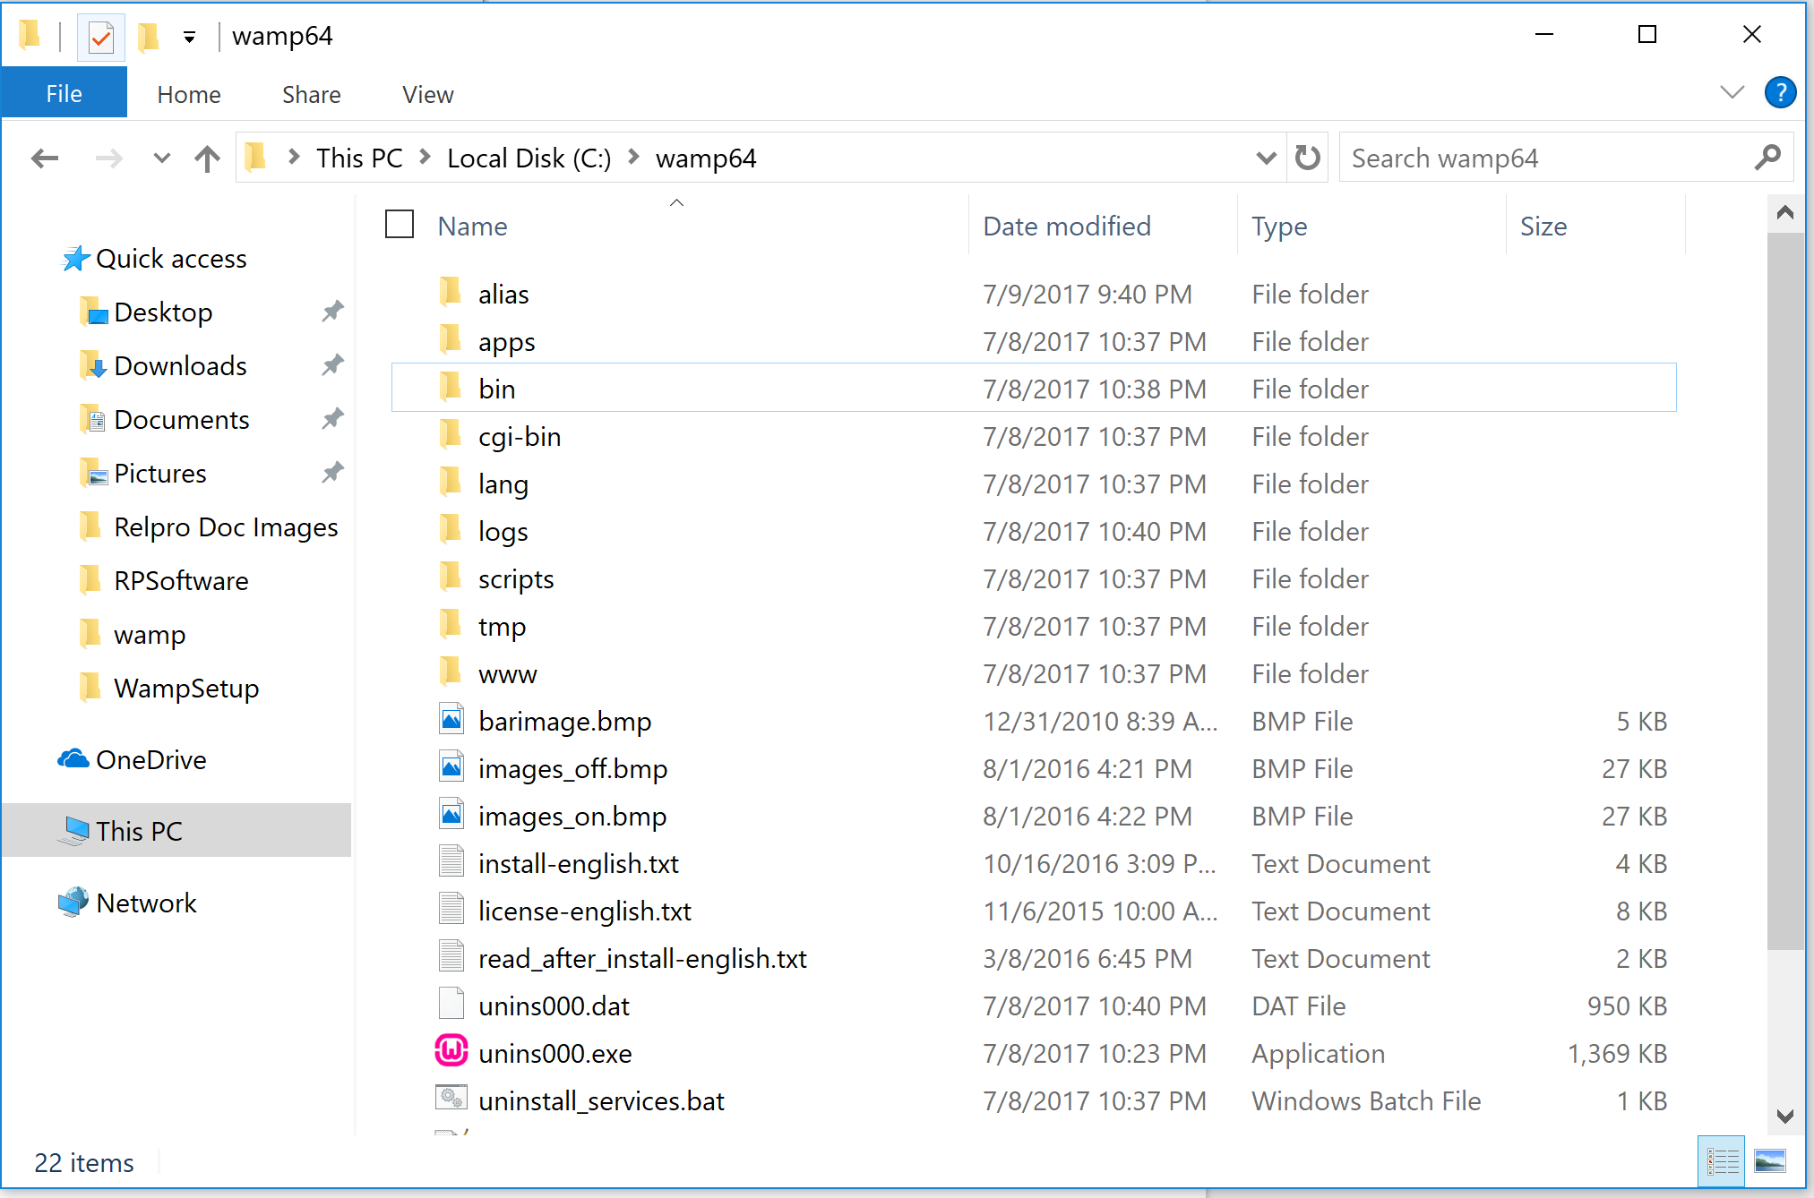
4. Go To C:\RPSoftware\WampSetup Directory. In this folder you will see 4 folders (alias, backup, vhosts, vhosts_config). Select these 4 folders and copy them into the C:\wamp64 Directory.   
   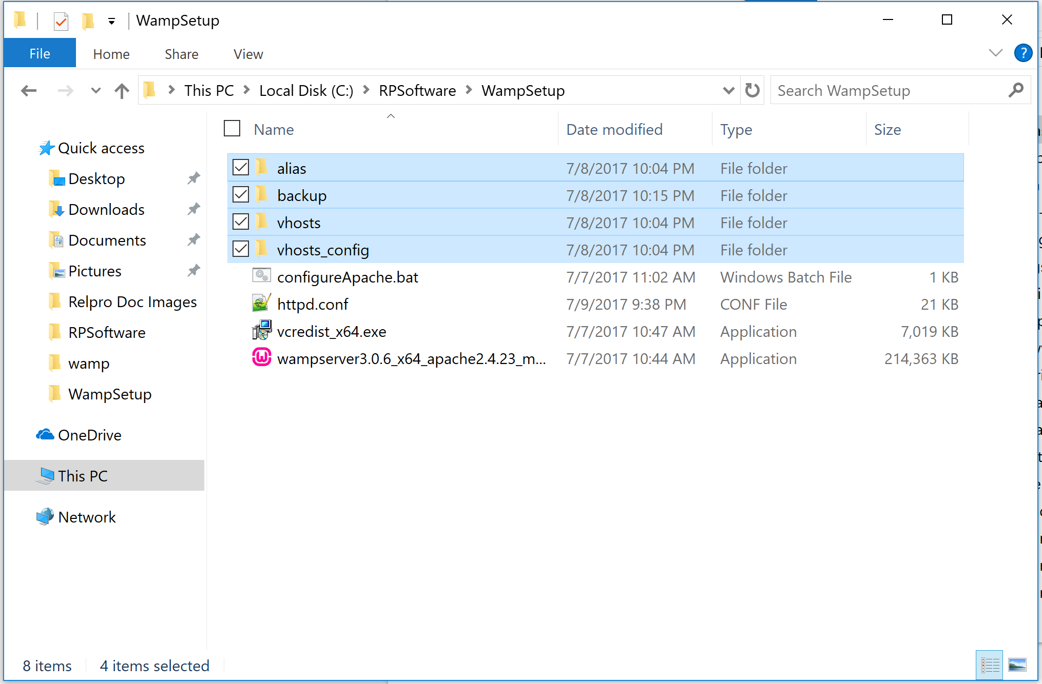  
   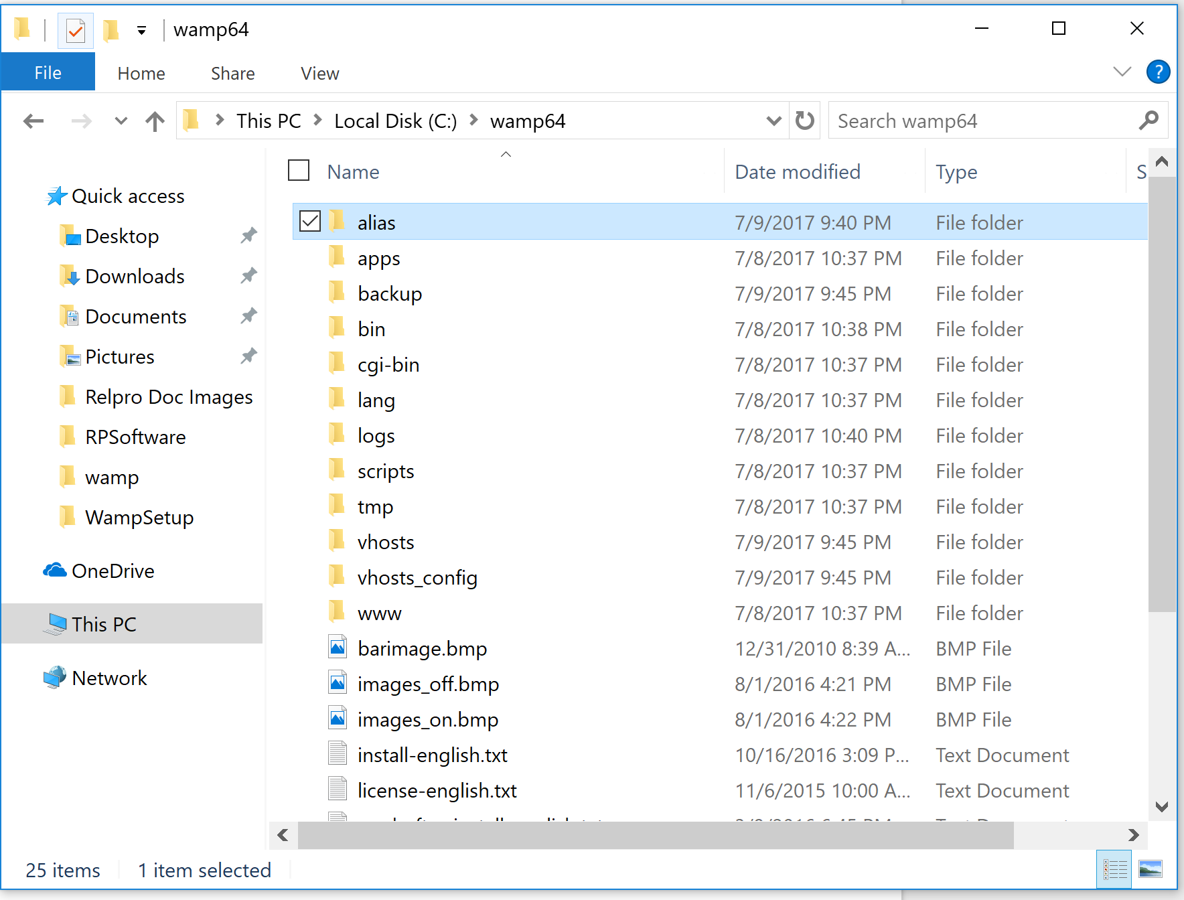
5. In C:\RPSoftware\WampSetup Directory copy file “httpd.conf” to C:\wamp64\bin\apache\apache2.4.23\conf. Overwrite the original file.
6. In C:\RPSoftware\WampSetup Directory. Run File configureApache.bat.
7. Last Step open up wamp server “Wampserver64” to see if all configuration worked correctly.  
   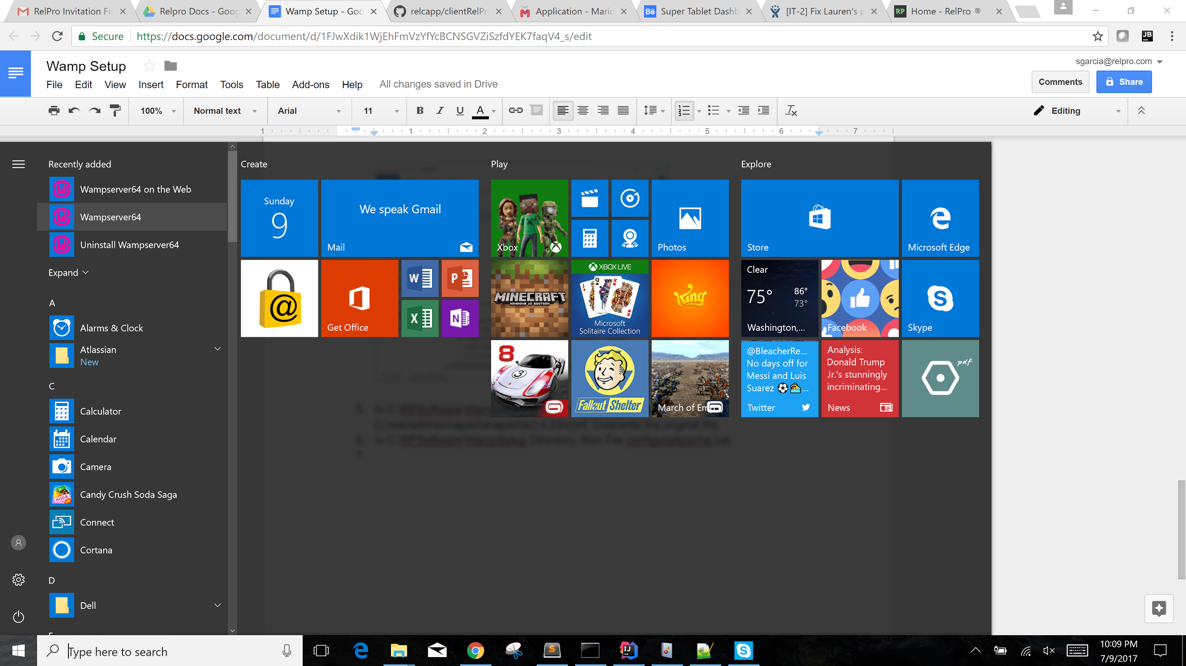
8. If all worked correctly, you should look at your hidden icons to see if the “W” is green, also you can go to localhost in your web browser and this will take you to the relpro app login screen.   
     
   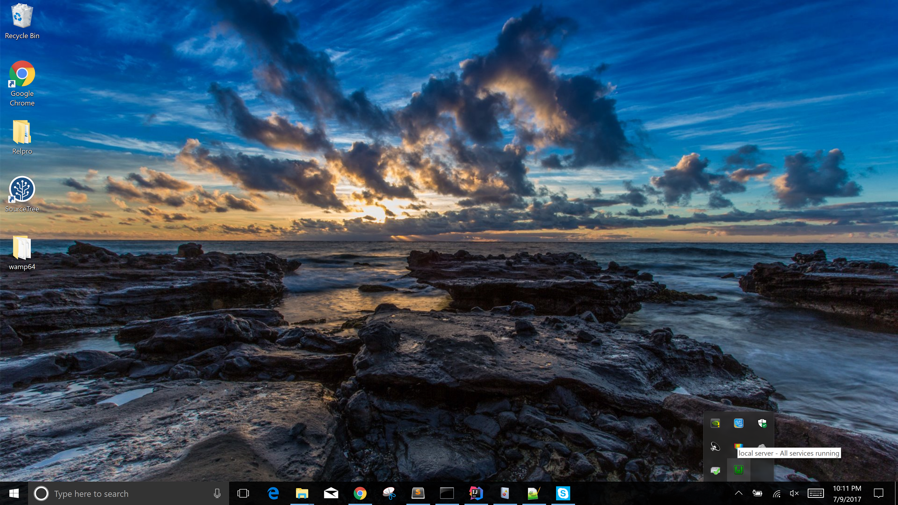   
     
   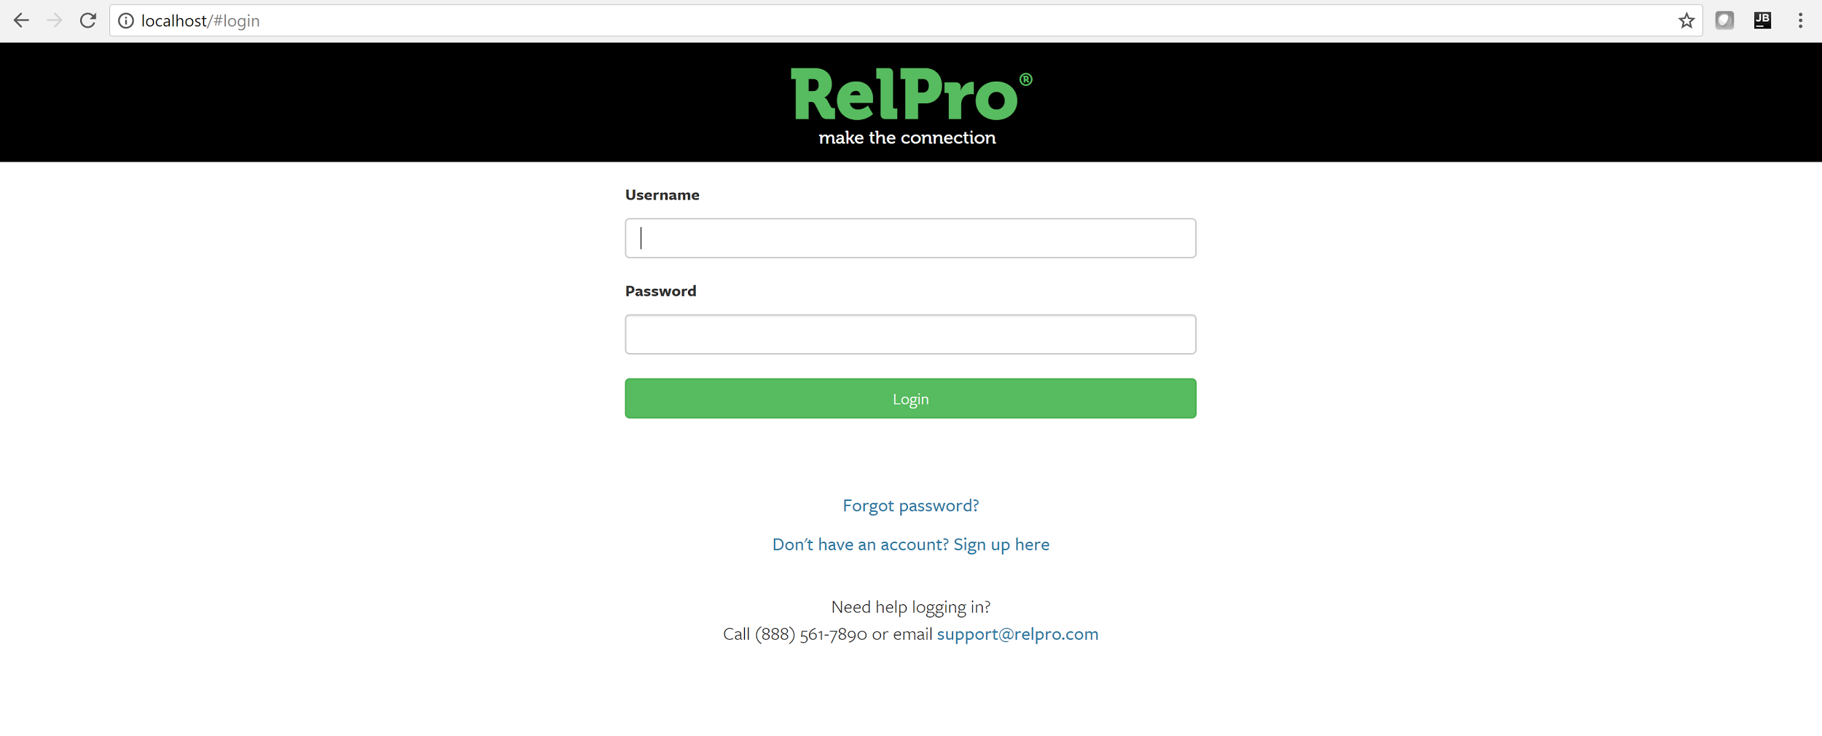
9. If all of this works correctly, installation and setup is complete.